ITA0601 – MACHINE LEARNING
LAB EXPERIMENTS
EXP-17: Mobile Price Prediction using appropriate machine learning algorithm
Dataset 1 – Mobile Price Prediction
RAM (GB) | Storage (GB) | Battery (mAh) | Camera (MP) | Price (₹)
2 | 32 | 3000 | 12 | 9000
3 | 32 | 3500 | 13 | 11000
4 | 64 | 4000 | 16 | 14000
4 | 128 | 4500 | 20 | 17000
6 | 128 | 5000 | 24 | 21000
6 | 256 | 5000 | 32 | 25000
8 | 128 | 5000 | 48 | 28000
8 | 256 | 5500 | 50 | 32000
12 | 256 | 5500 | 64 | 38000
12 | 512 | 6000 | 108 | 45000
Python Code:
import pandas as pd
from sklearn.linear_model import LinearRegression
data = {
"RAM": [2, 3, 4, 4, 6, 6, 8, 8, 12, 12],
"Storage": [32, 32, 64, 128, 128, 256, 128, 256, 256, 512],
"Battery": [3000, 3500, 4000, 4500, 5000,
5000, 5000, 5500, 5500, 6000],
"Camera": [12, 13, 16, 20, 24, 32, 48, 50, 64, 108],
"Price": [9000, 11000, 14000, 17000, 21000,
25000, 28000, 32000, 38000, 45000]
}
df = pd.DataFrame(data)
X = df[["RAM", "Storage", "Battery", "Camera"]]
y = df["Price"]
model = LinearRegression()
model.fit(X, y)
new_mobile = pd.DataFrame({
"RAM": [8],
"Storage": [256],
"Battery": [5000],
"Camera": [50]
})
prediction = model.predict(new_mobile)
print("Predicted Mobile Price: ₹",
round(prediction[0], 2))
Output:
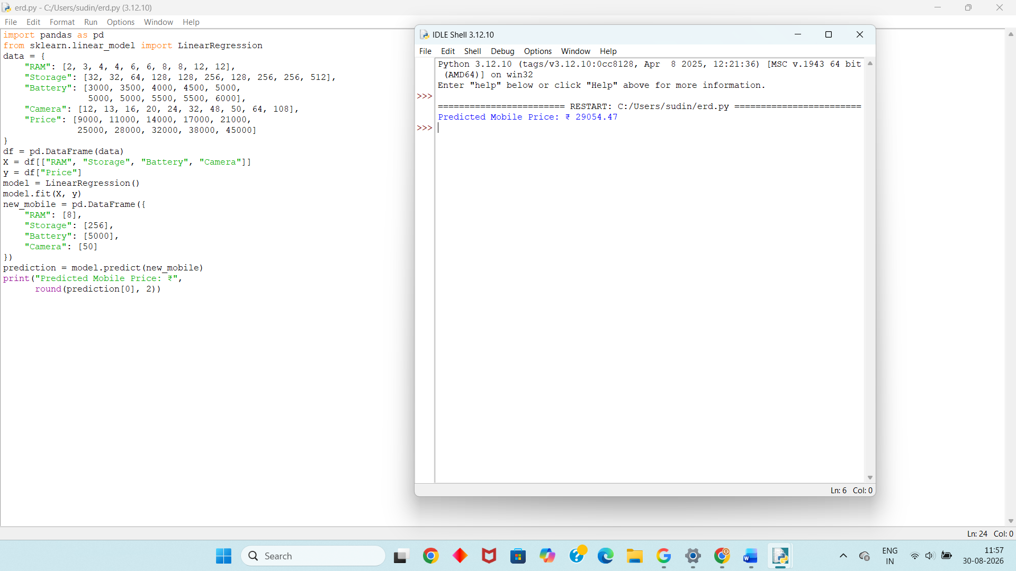
Dataset 2 – Mobile Price Prediction
RAM (GB) | Storage (GB) | Battery (mAh) | Camera (MP) | Price (₹)
2 | 32 | 3200 | 8 | 8000
3 | 64 | 3500 | 12 | 10500
4 | 64 | 4000 | 16 | 13500
4 | 128 | 4500 | 20 | 16000
6 | 128 | 4800 | 32 | 20000
6 | 256 | 5000 | 48 | 24000
8 | 128 | 5000 | 50 | 27000
8 | 256 | 5200 | 64 | 30000
12 | 256 | 5500 | 64 | 37000
12 | 512 | 6000 | 108 | 44000
Python Code:
import pandas as pd
from sklearn.linear_model import LinearRegression
data = {
"RAM": [2, 3, 4, 4, 6, 6, 8, 8, 12, 12],
"Storage": [32, 64, 64, 128, 128, 256, 128, 256, 256, 512],
"Battery": [3200, 3500, 4000, 4500, 4800,
5000, 5000, 5200, 5500, 6000],
"Camera": [8, 12, 16, 20, 32, 48, 50, 64, 64, 108],
"Price": [8000, 10500, 13500, 16000, 20000,
24000, 27000, 30000, 37000, 44000]
}
df = pd.DataFrame(data)
X = df[["RAM", "Storage", "Battery", "Camera"]]
y = df["Price"]
model = LinearRegression()
model.fit(X, y)
new_mobile = pd.DataFrame({
"RAM": [6],
"Storage": [128],
"Battery": [4800],
"Camera": [32]
})
prediction = model.predict(new_mobile)
print("Predicted Mobile Price: ₹",
round(prediction[0], 2))
Output:
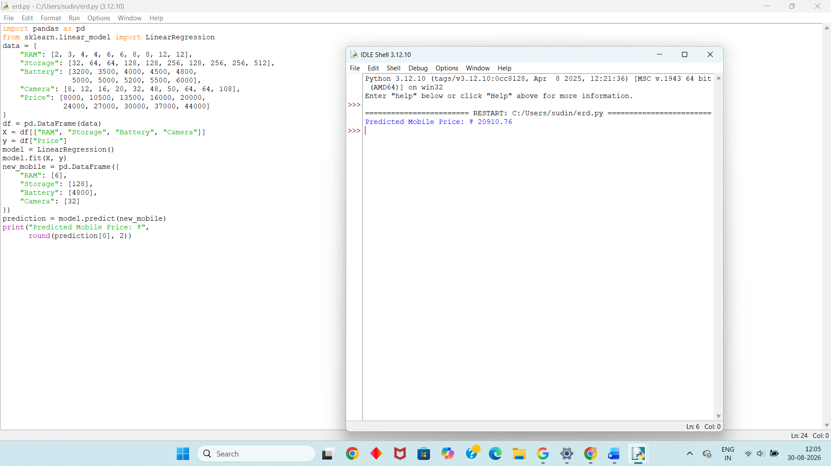
Dataset 3 – Mobile Price Prediction
RAM (GB) | Storage (GB) | Battery (mAh) | Camera (MP) | Price (₹)
2 | 32 | 3000 | 10 | 8500
3 | 32 | 3500 | 12 | 10000
4 | 64 | 4000 | 16 | 13000
4 | 128 | 4500 | 20 | 15500
6 | 128 | 4800 | 32 | 19500
6 | 256 | 5000 | 48 | 23000
8 | 128 | 5000 | 50 | 26500
8 | 256 | 5200 | 64 | 31000
12 | 256 | 5500 | 108 | 36500
12 | 512 | 6000 | 200 | 46000
Python Code:
import pandas as pd
from sklearn.linear_model import LinearRegression
data = {
"RAM": [2, 3, 4, 4, 6, 6, 8, 8, 12, 12],
"Storage": [32, 32, 64, 128, 128, 256, 128, 256, 256, 512],
"Battery": [3000, 3500, 4000, 4500, 4800,
5000, 5000, 5200, 5500, 6000],
"Camera": [10, 12, 16, 20, 32, 48, 50, 64, 108, 200],
"Price": [8500, 10000, 13000, 15500, 19500,
23000, 26500, 31000, 36500, 46000]
}
df = pd.DataFrame(data)
X = df[["RAM", "Storage", "Battery", "Camera"]]
y = df["Price"]
model = LinearRegression()
model.fit(X, y)
new_mobile = pd.DataFrame({
"RAM": [8],
"Storage": [256],
"Battery": [5200],
"Camera": [64]
})
prediction = model.predict(new_mobile)
print("Predicted Mobile Price: ₹",
round(prediction[0], 2))
Output:
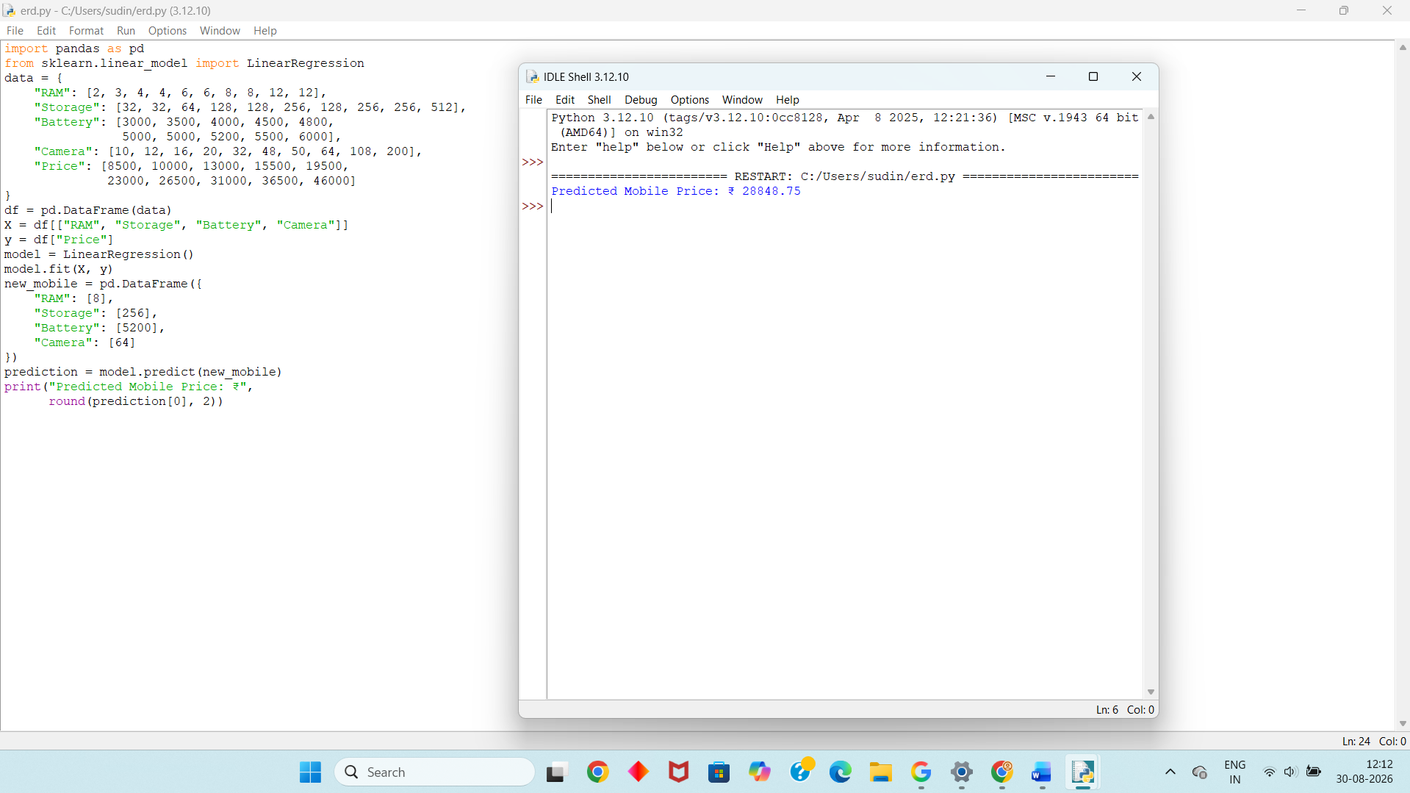
Dataset 4 – Mobile Price Prediction
RAM (GB) | Storage (GB) | Battery (mAh) | Camera (MP) | Price (₹)
2 | 32 | 2800 | 8 | 7500
3 | 64 | 3300 | 12 | 9500
4 | 64 | 4000 | 16 | 12500
4 | 128 | 4500 | 20 | 15000
6 | 128 | 4800 | 32 | 18500
6 | 256 | 5000 | 48 | 22500
8 | 128 | 5000 | 50 | 26000
8 | 256 | 5200 | 64 | 29500
12 | 256 | 5500 | 108 | 36000
12 | 512 | 6000 | 200 | 45500
Python Code:
import pandas as pd
from sklearn.linear_model import LinearRegression
data = {
"RAM": [2, 3, 4, 4, 6, 6, 8, 8, 12, 12],
"Storage": [32, 64, 64, 128, 128, 256, 128, 256, 256, 512],
"Battery": [2800, 3300, 4000, 4500, 4800,
5000, 5000, 5200, 5500, 6000],
"Camera": [8, 12, 16, 20, 32, 48, 50, 64, 108, 200],
"Price": [7500, 9500, 12500, 15000, 18500,
22500, 26000, 29500, 36000, 45500]
}
df = pd.DataFrame(data)
X = df[["RAM", "Storage", "Battery", "Camera"]]
y = df["Price"]
model = LinearRegression()
model.fit(X, y)
new_mobile = pd.DataFrame({
"RAM": [6],
"Storage": [256],
"Battery": [5000],
"Camera": [48]
})
prediction = model.predict(new_mobile)
print("Predicted Mobile Price: ₹",
round(prediction[0], 2))
Output:
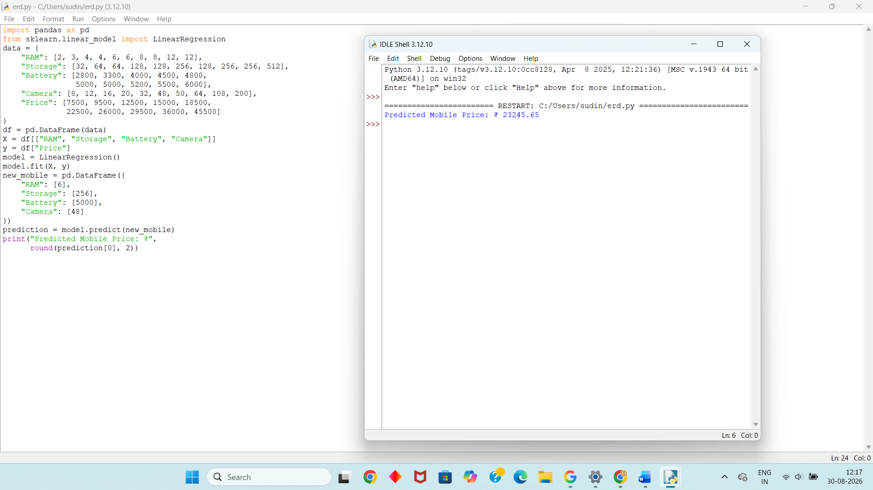
Dataset 5 – Mobile Price Prediction
RAM (GB) | Storage (GB) | Battery (mAh) | Camera (MP) | Price (₹)
2 | 32 | 3000 | 8 | 8500
3 | 64 | 3500 | 13 | 10500
4 | 64 | 4000 | 16 | 14000
4 | 128 | 4500 | 24 | 17000
6 | 128 | 5000 | 32 | 21500
6 | 256 | 5000 | 48 | 25500
8 | 128 | 5200 | 50 | 28500
8 | 256 | 5500 | 64 | 32500
12 | 256 | 5500 | 108 | 39000
12 | 512 | 6000 | 200 | 48000
Python Code:
import pandas as pd
from sklearn.linear_model import LinearRegression
data = {
"RAM": [2, 3, 4, 4, 6, 6, 8, 8, 12, 12],
"Storage": [32, 64, 64, 128, 128, 256, 128, 256, 256, 512],
"Battery": [3000, 3500, 4000, 4500, 5000,
5000, 5200, 5500, 5500, 6000],
"Camera": [8, 13, 16, 24, 32, 48, 50, 64, 108, 200],
"Price": [8500, 10500, 14000, 17000, 21500,
25500, 28500, 32500, 39000, 48000]
}
df = pd.DataFrame(data)
X = df[["RAM", "Storage", "Battery", "Camera"]]
y = df["Price"]
model = LinearRegression()
model.fit(X, y)
new_mobile = pd.DataFrame({
"RAM": [8],
"Storage": [256],
"Battery": [5500],
"Camera": [64]
})
prediction = model.predict(new_mobile)
print("Predicted Mobile Price: ₹",
round(prediction[0], 2))
Output:
